**BANK CHURN ANALYSIS**

**Project Overview**

This project focuses on analyzing bank customer data to uncover insights into financial behavior, credit utilization, income patterns, and risk assessment. Instead of solely concentrating on churn prediction, the objective is to leverage data-driven insights to enhance banking operations, optimize customer engagement, and improve financial decision-making.

Banks generate vast amounts of transactional and behavioral data, which, when analyzed effectively, can help refine customer segmentation, assess credit risk, detect potential fraud, and enhance financial product offerings. This project aims to transform raw banking data into actionable intelligence that drives **stability, customer retention, and profitability**.

**Key Areas of Analysis**

**1. Customer Segmentation**

* Categorizing customers based on **age, income level, education, and credit behavior**.
* Understanding spending habits and financial priorities across demographics.

**2. Credit Utilization & Risk Assessment**

* Identifying customers with **high credit utilization ratios**, indicating potential financial stress.
* Classifying customers into **low, moderate, and high credit risk categories**.

**3. Spending Behavior & Financial Health**

* Analyzing **income vs. expenditure patterns** to evaluate financial stability.
* Identifying customers with **low balances and high credit dependency**.

**4. High-Value Customer Identification**

* Recognizing **customers with high balances, premium credit cards, and long banking relationships**.
* Offering personalized services to maximize engagement and retention.

**5. Dormant & High-Risk Accounts**

* Detecting **customers with low transaction activity and long inactive periods**.
* Developing **re-engagement strategies** to improve retention and prevent attrition.

**Business Impact & Strategic Benefits**

**Enhanced Credit Risk Management** → Early identification of high-risk customers reduces defaults.  
**Personalized Banking Services** → Premium and high-net-worth customers receive targeted financial products.  
**Marketing Optimization** → Banks can focus on **high-potential customers** for loans, credit cards, and investment products.  
**Improved Customer Retention** → Proactive engagement with dormant customers strengthens long-term relationships.

**1.Total Customers:**

select COUNT(clientnum) as Total_Customers from bank_churn_data

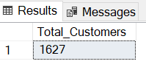

**2. Count Churned vs. Active Customers**

**Counts how many customers have churned vs. how many are still active.:**

SELECT churn, COUNT(clientnum) AS customer_count

FROM bank_churn_data

GROUP BY churn;

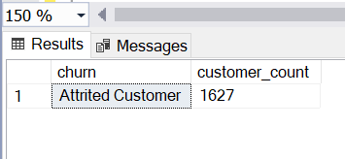

**3. Customer Distribution by Card Category**

**Counts how many customers have each type of credit card.**

SELECT card_category, COUNT(clientnum) AS customer_count

FROM bank_churn_data

GROUP BY card_category

ORDER BY customer_count DESC;

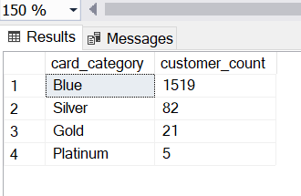

**4. Average Credit Limit per Income Level**

**Finds the average credit limit based on customer income levels.**

SELECT income, AVG(credit_limit) AS avg_credit_limit

FROM bank_churn_data

GROUP BY income

ORDER BY avg_credit_limit DESC;

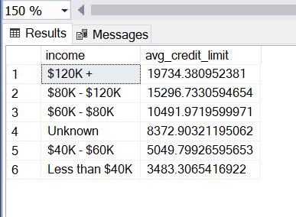

**5. Customers Segmentation by Age Group**

**Groups customers into different age brackets.**

SELECT

CASE

WHEN customer_age BETWEEN 18 AND 25 THEN '18-25'

WHEN customer_age BETWEEN 26 AND 35 THEN '26-35'

WHEN customer_age BETWEEN 36 AND 45 THEN '36-45'

WHEN customer_age BETWEEN 46 AND 55 THEN '46-55'

ELSE '56+'

END AS age_group,

COUNT(clientnum) AS total_customers

FROM bank_churn_data

GROUP BY CASE

WHEN customer_age BETWEEN 18 AND 25 THEN '18-25'

WHEN customer_age BETWEEN 26 AND 35 THEN '26-35'

WHEN customer_age BETWEEN 36 AND 45 THEN '36-45'

WHEN customer_age BETWEEN 46 AND 55 THEN '46-55'

ELSE '56+'

END

ORDER BY total_customers DESC;

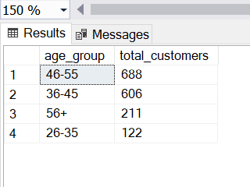

**6. Customers with Highest Credit Limit (Top 10)**

**Finds the top 10 customers with the highest credit limits.**

SELECT TOP 10 clientnum, customer_age, income, credit_limit

FROM bank_churn_data

ORDER BY credit_limit DESC;

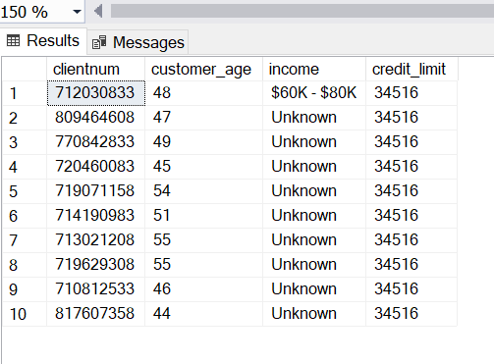

**7. Average Account Balance per Marital Status**

**Finds the average balance for customers based on their marital status.**

SELECT marital_status, AVG(balance) AS avg_balance

FROM bank_churn_data

GROUP BY marital_status

ORDER BY avg_balance DESC;

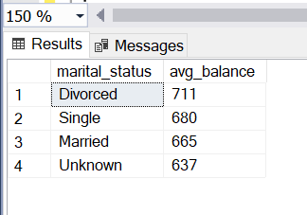

**8. Total Number of Customers by Gender**

**Counts male vs. female customers.**

SELECT gender, COUNT(clientnum) AS total_customers

FROM bank_churn_data

GROUP BY gender;

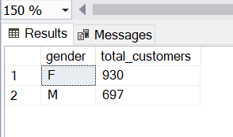

**9. Customers Who Have More than 3 Dependents**

**Finds customers with large financial responsibilities**.

SELECT clientnum, customer_age, income, dependent_count

FROM bank_churn_data

WHERE dependent_count > 3

ORDER BY dependent_count DESC;

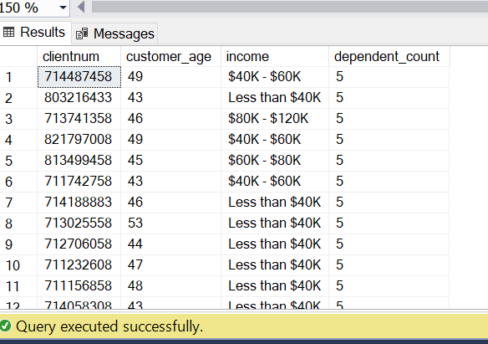

**10. Average Credit Utilization by Income Group**

**Finds the average credit utilization per income category.**

SELECT income, AVG(utilization_ratio) AS avg_utilization

FROM bank_churn_data

GROUP BY income

ORDER BY avg_utilization DESC;

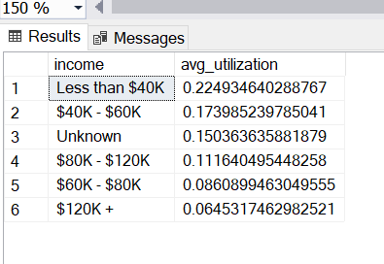

**11.Longest Relationship Customers (VIP Segmentation)**

SELECT

clientnum,

customer_age,

months_on_book,

income,

balance,

credit_limit

FROM bank_churn_data

WHERE months_on_book > 53

ORDER BY balance DESC;

